MapleSyrup

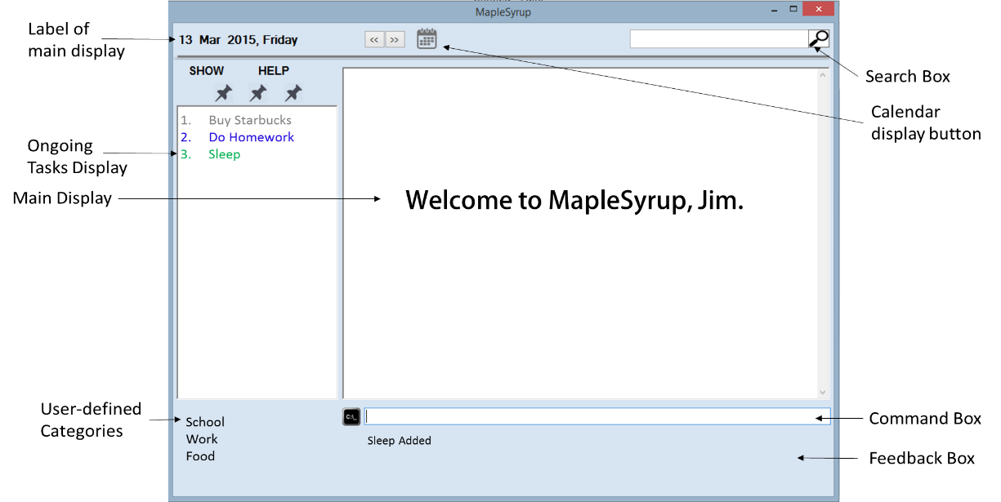

Supervisor: Lim Yu De Extra feature: GoodGUI

|  |  |  |  |
| --- | --- | --- | --- |
| wj  Ong Wei Jee  Team Lead Code Quality | George Passport Pic1  George Lam Changwei  Github Expert Documentation | Ter Yong Kang  GUI Designer Deliverables and Deadlines | che  Che Jian Yong Joshua  Integration Scheduling and tracking |

# User guide

**Introduction**

Welcome to MapleSyrup, your go to application to keep track of tasks and events. An event in MapleSyrup consists of several details: the name, date, time and additional descriptions. In this guide, we will walk through the process of adding, deleting, editing, displaying events, undoing and redoing.

**Getting Started**

1. Double click MapleSyrup on your desktop.
2. A welcome message will appear to greet you when the program opens.
3. The main display will show all your tasks and events for today. On-going tasks will be permanently displayed on the left column.

**Functions**

* **ADDING AN EVENT**

**Description:**   
Events (or tasks) can be added with the command **add**. They must have an event name, and can be assigned dates, from a starting date to an ending date, and timings, from a starting time to an ending time, as well as importance level as indicated by ‘!’. Events can also be specified as a deadline events.

**General format:**   
“**add** [event name] [status] [importance] [date] [time]”  
An event name is compulsory for all events. Date, time, status (deadline, ongoing) and importance are optional and can be omitted.

**Types of Events:**

Ongoing Events

To add Ongoing Events, only an event name is needed.  
“**add** [event name]”

Single Day Events

To add Single Day Events, one date has to be specified.

“**add** [event name] [date] [start time]-[end time]”

Variations:

If start time is specified only, end time will be set 1 hour after start time.

If no timing is specified, it will be considered a full day event.

Multiple Day Events

To add Multiple day events, a starting date and an ending date is required.

“**add** [event name] [start date] [start time] – [end date] [end time]”

Variations:

If only start time is specified, the last day will be considered full day.

If only end time is specified, the event start time will be 12am of the first day.

If no timing is specified, it will be taken as a multiple full day event.

Deadline Events

Adding Deadline events require a **due** or **by** word. Deadline events can only accept a maximum of 1 date and 1 time input.  
“**add** [event name] **by** [date] [time]”

Important Events  
Events can also be assigned an importance level. There are 3 levels of importance, and are indicated by the number of **!** used, **!** meaning 1 importance level and **!!!** being 3 importance level.  
“**add** [event name] **!!!** [date] [time]”

**Display of added events:**

Ongoing events are displayed on the left and normal events with date and time are displayed in the central box, in a list view format from the earliest date at the top to the latest date at the bottom.

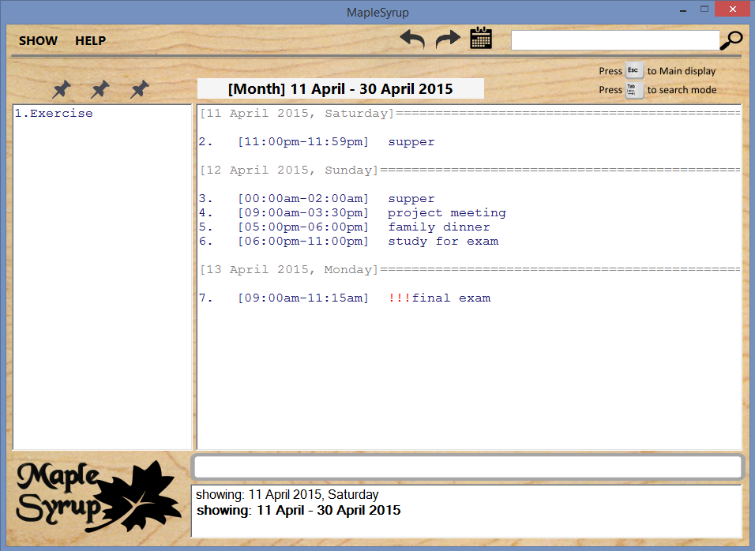

When a new event is added, it will be highlighted in green on display. All other existing events will be displayed in blue.

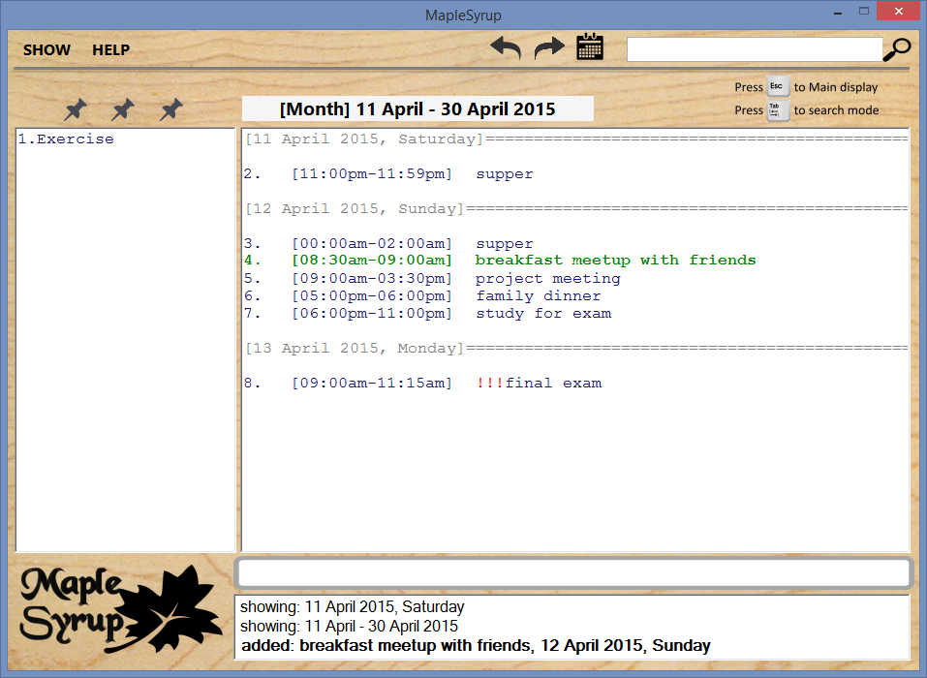  
  
If there is a clash of timing between the newly added event and existing events, both events will be highlighted in red to warn of the clashing. The event in bold is the newly added event.

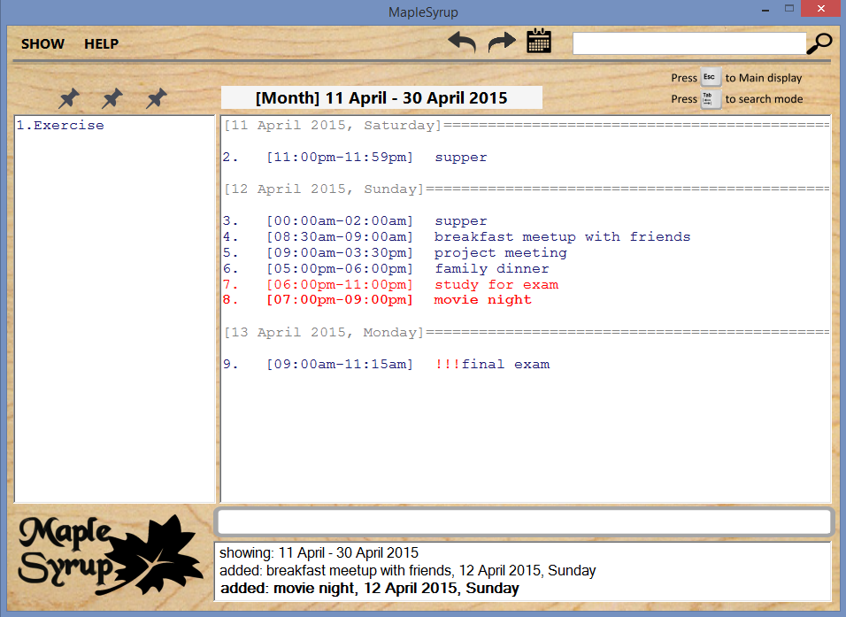

**Recognisable forms of date and time:**  
Date:  
14apr / 14april / 14 apr  
today / tdy / tomorrow / tmr / mon / tues / wed / thurs / fri / sat / sun   
next mon/tues/...  
  
Time:  
1am / 1 am / 1.30 am / 1.30am

* **SEARCHING FOR AN EVENT**

**Description:**

The search bar is located at the top right of the window and it can be accessed by pressing TAB when you are in the command box.

The search results will update every time a new character is typed into the search bar.

Press TAB to go back to the command line after you are done searching.

* **EDITING AN EVENT**

**Description:**

All details of an event, from its event name, date, time to its status can be edited by using the command **edit**.

**General format:** (excluding “” & [])

“**edit** [event name/index]**;** [new event name] [new importance] [new date] [new time]”

To edit, the event name or index of the event to be edited is compulsory. After the event name or index, type in a **;** before adding the new details for the event. For the new details of the event, only those that you wish to be edited is required, all other details that are omitted will be kept the same.

**Types of editing:**

Normal editing

Only type in details that you wish to be edited, all other details will be left untouched.

“**edit** [event name/index]**;** [new event name] [new importance] [new date] [new time]”

Normal event to ongoing event

To remove the time and date of an event, which will convert it to an ongoing event, simply omit all new details.

“**edit** [normal event name/index]**;**”

Ongoing event to normal event

Additionally, ongoing events can be edited to a normal event if new dates or new timings are specified.  
“**edit** [ongoing event name/index]; [date] [time]”  
  
**Special Cases:**

More than one event with the same name  
If there

* **DELETING AN EVENT**

**Description:**

Any event can be deleted simply by using the **del** or **delete** command.

**General format:**

“**del** [event name/index]”

Either event name or the event index on display can be used to delete an event. Although multiple day events have a different indexes on different days, using any one of its indexes will delete the entire event.

**Special Cases:**

More than one event with the same name  
Follow the same procedure as mentioned above in “Editing an event”.

* **DISPLAYING EVENTS**

**Description:**

If you need to find all events within a period, or important events, the **show** command can assist you. When you use a show command, the display will be updated to the date range that you specified.

**General format:**

“**show** [dates to show/importance]”

**Types of show:**

Single day

“**show** 24apr”

Multiple days

“**show** 22-23apr”

“**show** week”

Month

“**show** month”

“**show** april”

“**show** apr-may”

Year

“**show** year”

“**show** 2015-2016”

Others

“**show** all”

“**show** impt”